Mentor Handbook:

A Guide by the Havird Lab

Hello Havird Lab Mentor!

As a member of the lab, there are a few responsibilities our lab has agreed upon for each mentor to abide by. Being a mentor to young researchers is an often undervalued and responsibility of grad students, post-docs, and PI’s in academia and we in the Havird lab strive to do better. Here are just a few tasks we ask all lab mentors to follow with each of their mentees.

# Tasks & Duties

1. Send this onboarding email to your student:

*Welcome to the Havird Lab!!*

*We are happy to have you join us. This email contains some basic information about the lab as well as a couple of tasks you will need to complete within the first 2 weeks of joining the lab.*

*Lab Spaces:*

1. *The main lab space is NMS 4.324. Some things to keep in mind with this space: Most of the desks and lab benches are dedicated to individual lab members. There is one benchmarked “undergraduates” with pipettes that you are free to use. You are welcome to use my bench as well. Please try and refrain from using pipettes or other equipment/reagents on other lab members’ benches without permission.*
2. *Be mindful that this is a lab BSL 1 lab space*

*We also have an office space in NMS 4.. There is a small shrimp room in NMS 4.*

*Onboarding Tasks:*

1. *Talk to your mentor about getting keys and card access to the building.*
2. *Email Justin (jchavird@utexas.edu) to:*
   1. *Request safety training*
   2. *Email a photo of yourself for the lab website if you are comfortable with that. (*[*https://sites.cns.utexas.edu/havird/home*](https://sites.cns.utexas.edu/havird/home)*)*
3. *Use this Document to complete all required Onboarding Tasks:* [*Mentee Handbook*](https://docs.google.com/document/d/1EF6XQNsSGW4LrySqmheXyMoAZvqXdQBiBTTdVnxf-rI/edit?usp=sharing)
4. *Add your information to the emergency contact sheet:* [*Havird Lab Emergency Contacts*](https://docs.google.com/spreadsheets/d/1Ait_VNTTxMQv2p3C8ijJqdnQtV6ayp6yDo8X1Jo_5aM/edit?usp=sharing)
5. *If you would like course credit, use the form on* [*https://ugs.utexas.edu/our/conduct/credit*](https://ugs.utexas.edu/our/conduct/credit)

*Importantly, the main goal of this research opportunity is to help you achieve your future goals.*

1. Send a welcome email to the lab that includes the following information:
   1. Name and year
   2. Project Title and what part they will play in said project
   3. If they’re with a program/internship please list
   4. If they are affiliated with another lab (i.e. you are co-advised and they will be working between both labs) please list.
   5. Any additional information you would like
2. Determine compensation. If a student has been in the lab for at least a semester, they should be compensated. This may include direct funding, funding from an external internship/REU/program, or course credit.
   1. **\*\*Remember,** **students only have until the 4th day of classes at the beginning of the semester to sign up for course credit**\*\*
   2. See the bottom of this document for steps on signing students up for credit
3. Complete the mentor-mentee Contract. The mentee should reach out to you to schedule a meeting to discuss this contract.
4. Schedule a personal meeting with each mentee once a semester outside of the lab. This is **not** a work meeting, it's a personal check-in. Things to discuss can include:
   1. How classes are going
   2. What they do for fun around austin/hobbies
   3. Ask about friendships etc.
   4. Ask how they feel about research in the abstract (do they see a future with it)
   5. What do they want to do after they graduate

Course Credit:

Whenever possible, undergrads should be getting course credit. You should be familiar with how the course credit system works so you can help your students if they have questions. Remember, students only have until the **4th day of classes** at the beginning of the semester to sign up for course credit.

### How to Apply for Course Credit:

* Go to <https://cns.utexas.edu/biosciences-advising-center/research-credit> and select the discipline that best represents your degree or interests: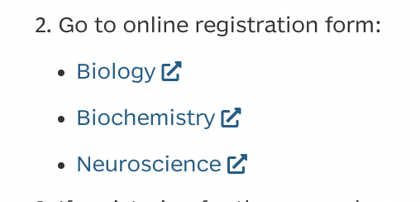
* Once you’ve chosen your discipline, click the orange arrow in the bottom right corner.
* Fill out the first page
* Discuss with your mentor how many credit hours to sign up for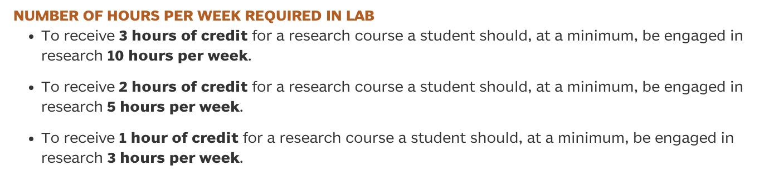
* Select the course that matches your course credit hour: Bio 177= 1 credit hour, Bio 277= 2 credit hours, Bio 377= 3 credit hours.

